Completing Program Evaluations for Site
Prism
While supervising a student, the program may request you to complete a form / evaluation on Exxat. Here is what you can expect!
- You will receive an email which contains a link to access the form. Click on the link or copy and paste it into your browser.
  - Please note, Internet Explorer is NOT a supported web browser.

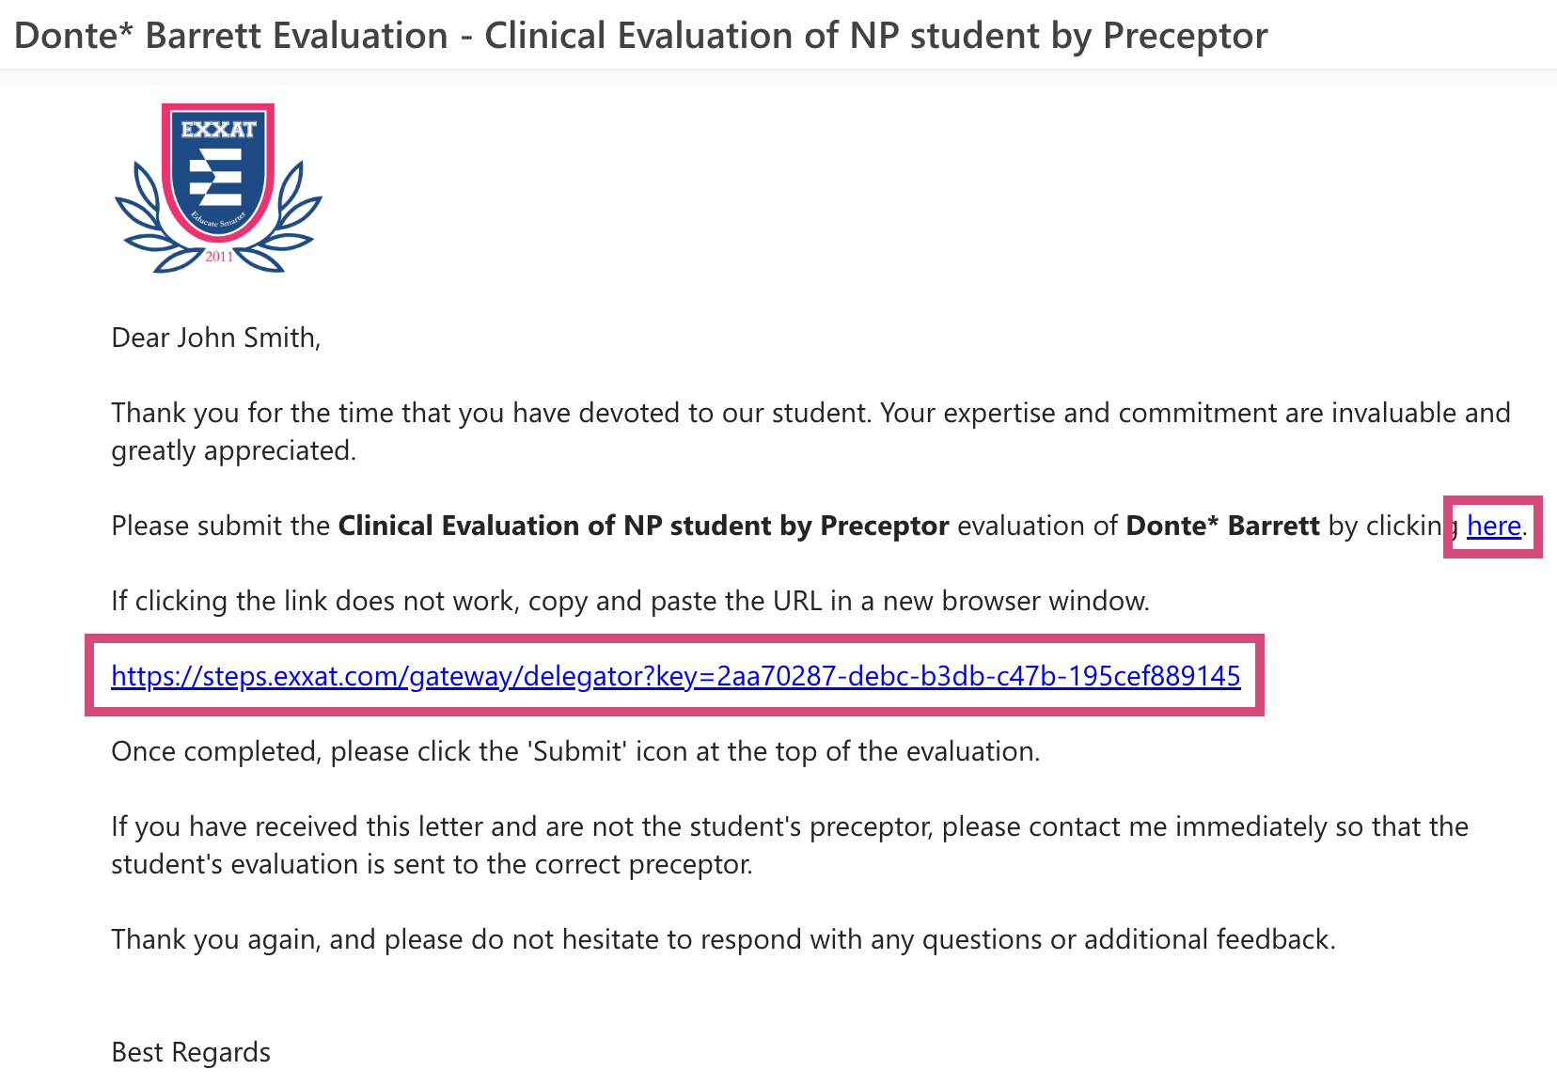

- The form will load, and you can begin completing it.
  - Click Clear All if you’d like to remove any responses.
  - Click Save to save your work and complete the form at a later time.

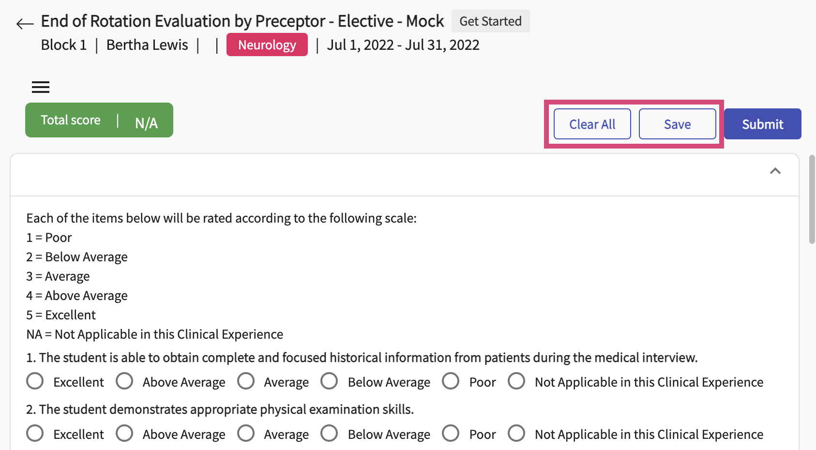

- Once done with the form, click Submit.

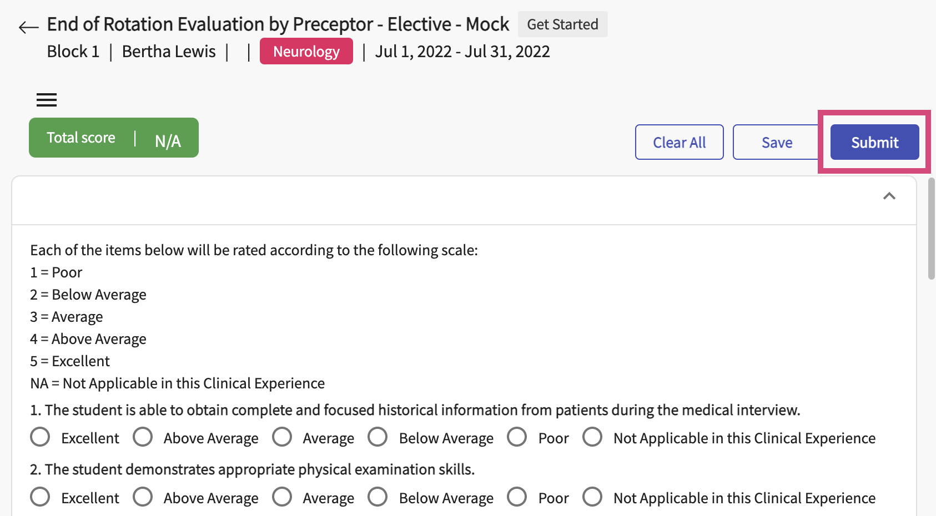

- A pop-up will appear. Click OK.

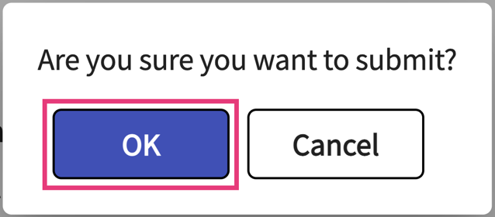

- The system will confirm you’re all done! Click on the link if you’d like to view your submitted responses.

