Reviewing Student Timesheets for Site
Prism
When working with students during a rotation, the school may request you to review and sign off on the student’s timesheets.
- Once a student submits their timesheet, you will be sent an email with a subject line “Student Name – Review Request for Timesheets”. Click on the link to review their timesheet.
  - Caution: the link automatically expires within 60 days!
  - Please note, Internet Explorer is not a supported browser.
  - If the link does not work, copy and paste the URL in a new window.

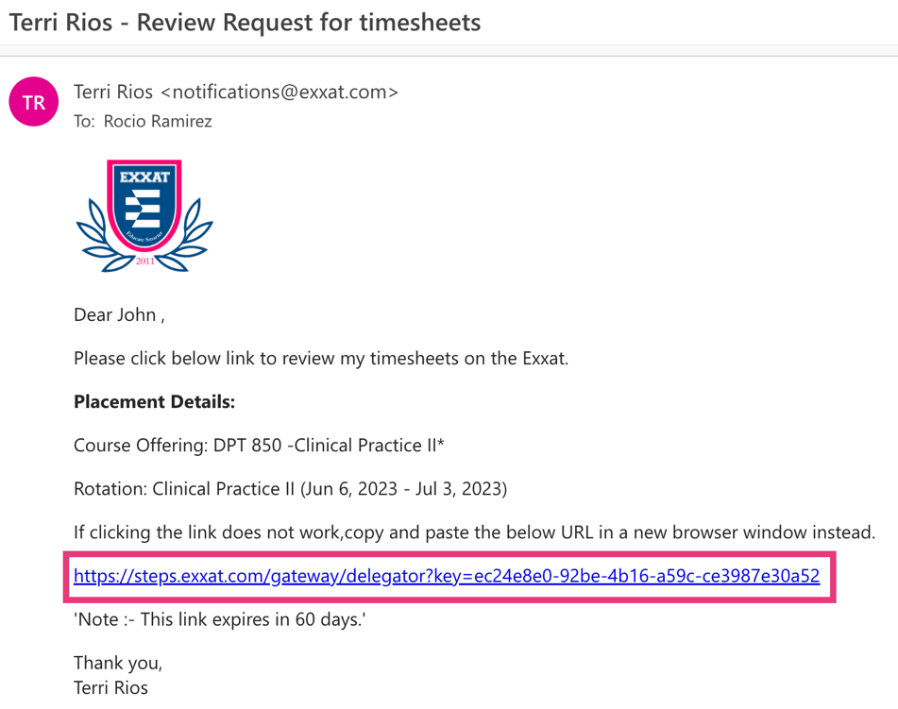

- You will be redirected to Exxat and will view all timesheets submitted by the student.
  - You can filter by dates and status.

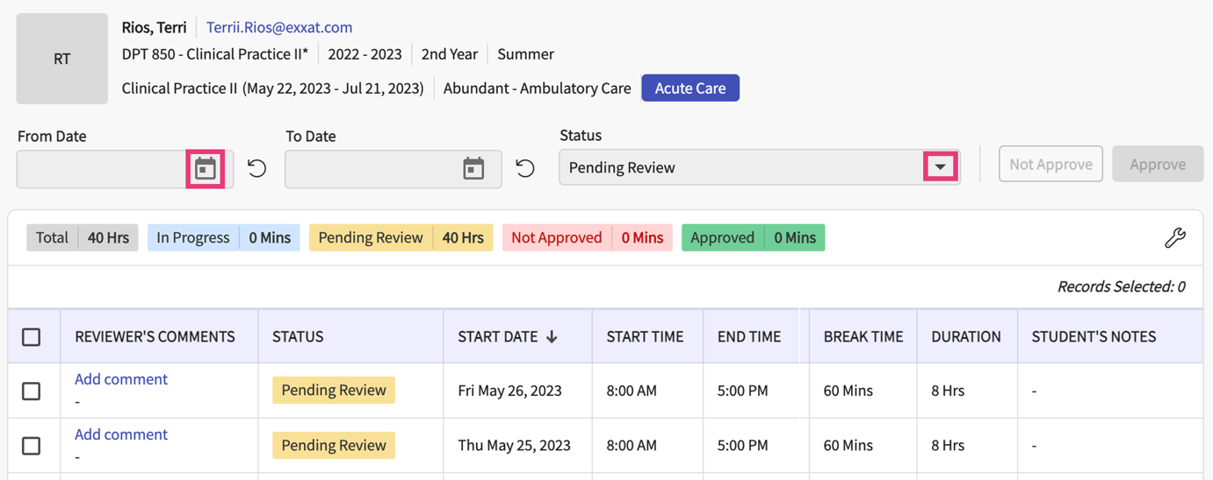

- If you’d like to make any comments on a specific time log, scroll to the right of the table and click Add Comment.
  - If the comment applies to multiple logs, select the logs first using the open checkbox.

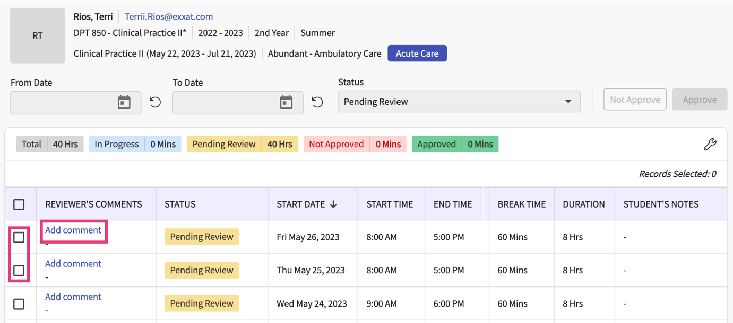

- A drawer will open. Provide your comments and click Save.
  - If you selected multiple timesheets, select the checkbox “Apply comments to all the selected records” option.

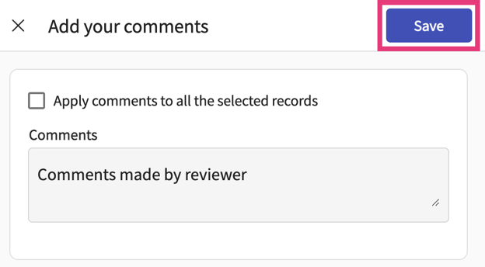

- Select the entries you’d like to review using the open checkbox and select Approve or Not Approve on the top right corner.

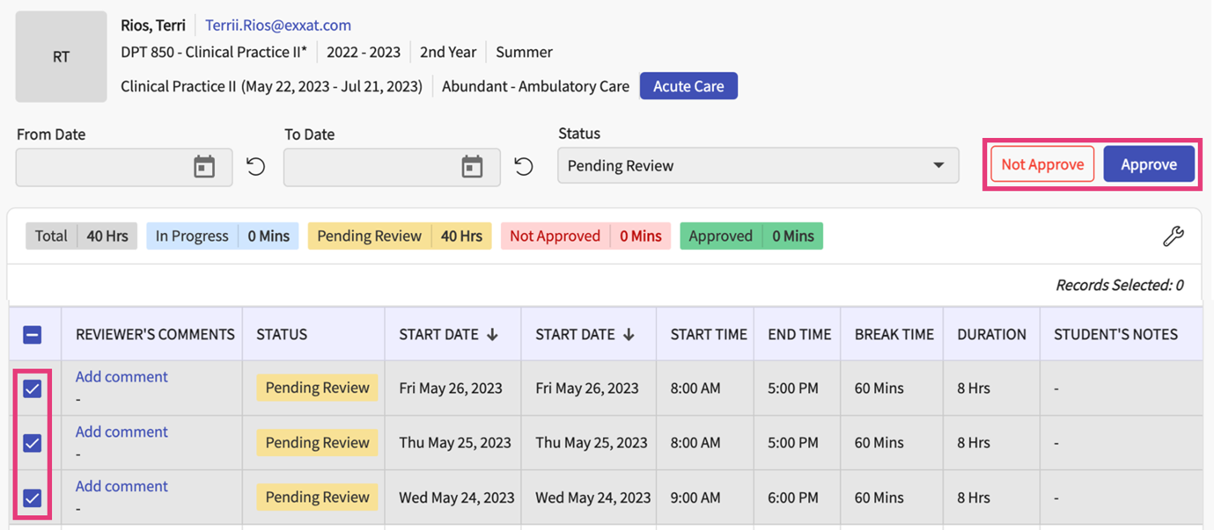

- A pop-up will appear asking you to confirm your review of the selected timesheets. Click Ok.

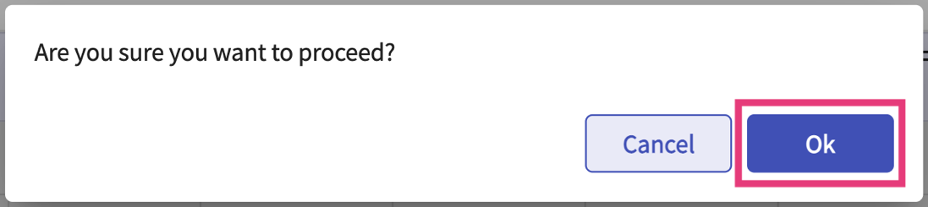

- The time entries you reviewed will be removed from the table. Any entries you have not yet reviewed will remain visible on the page.

