Viewing Program Resources for Site
Prism
Schools may share program information with you, get acquainted with the Program Resource Page!
- A school can share program information with you via a link.
- The link will give you access to their page, and no login information is necessary.
- Once you’ve accessed the link, the page will look similar to the image below and will contain the following sections:
  - Important announcements from the program
  - Clinical Education Schedule
  - Program Wide Resources for Clinicians
  - Course Specific Resources for Clinicians
  - Clinical Education Contacts.

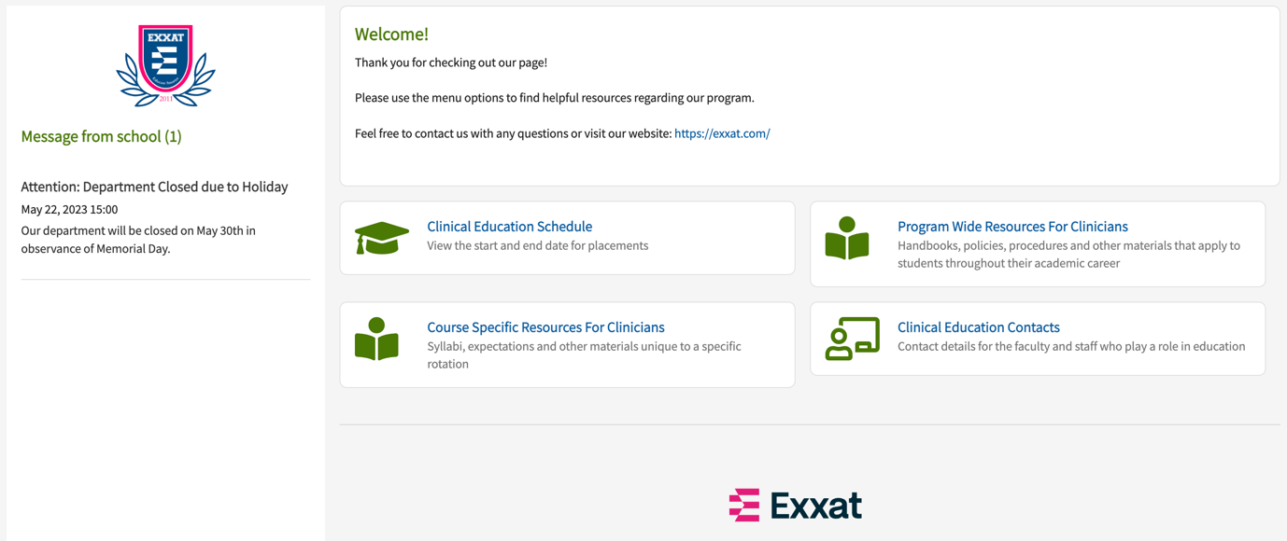

- Click on any card to view additional information.
  - You can also access them using the left menu.

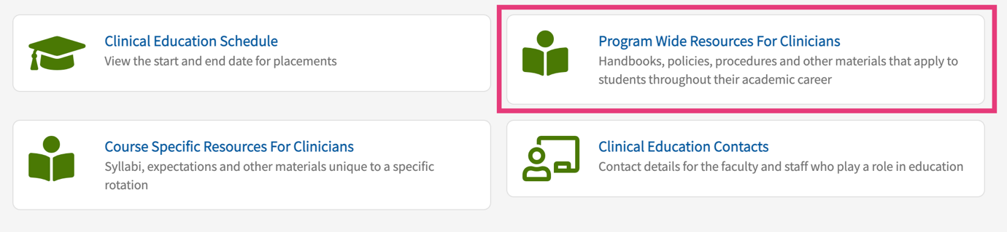

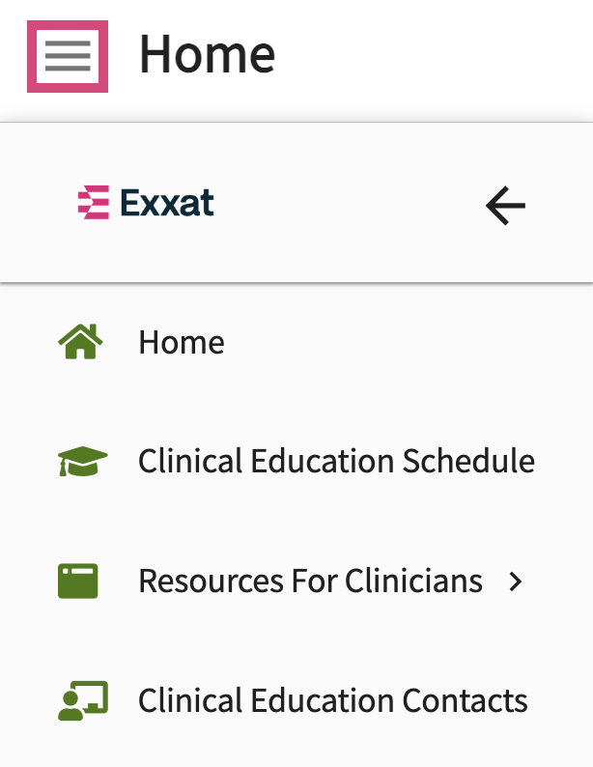

- Clinical Education Schedule: will show you all of the courses the program has scheduled.

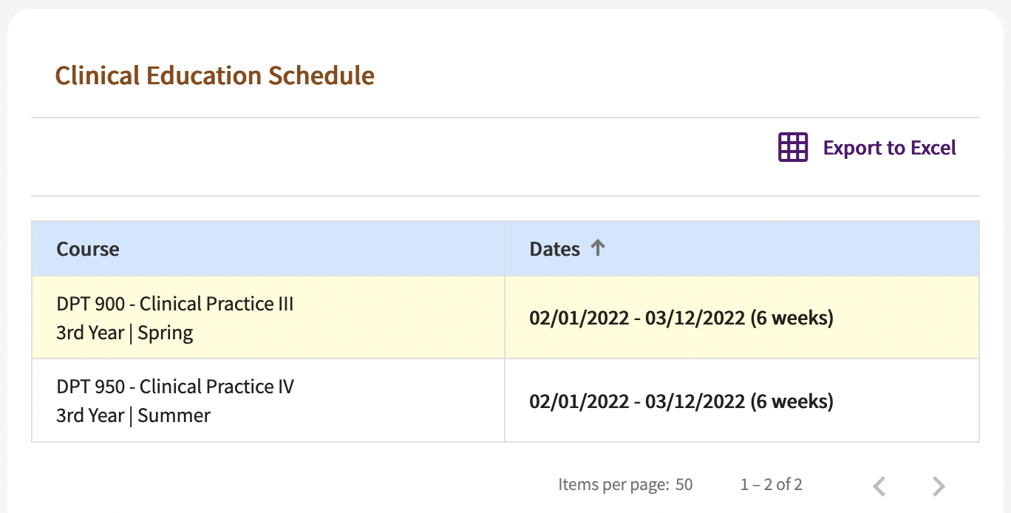

- Program Wide Resources for Clinicians: will have resources shared with you will be listed by category. Switch between them using the left-panel. You can also search within a category using the search box.

Filter by type of resources here

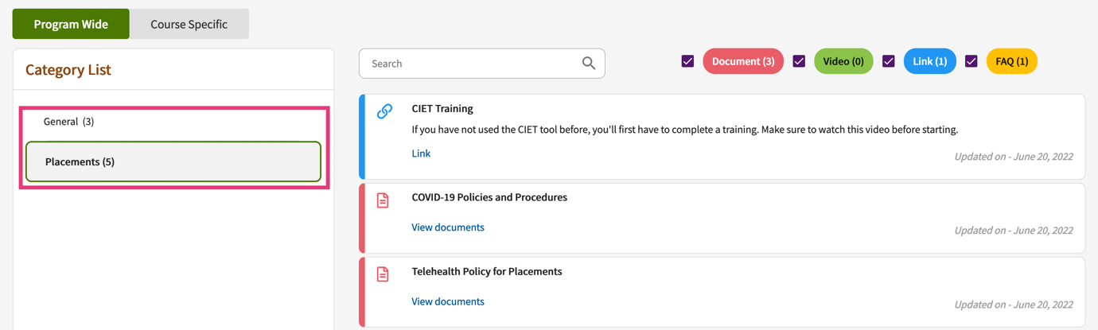

- Course Specific Resources for Clinicians: will have course specific resources that have been shared with you. Select the course offering from the left-panel, and you’ll then view resources by category.

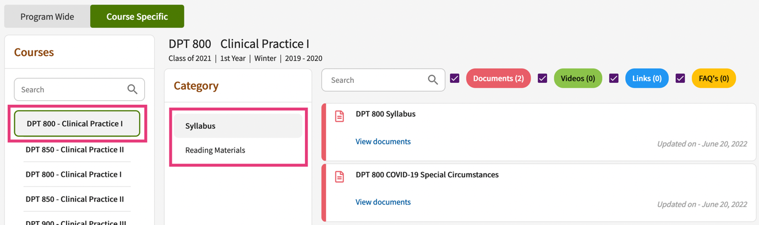

- Clinical Education Contacts: need to contact the program but unsure of who to contact? This section will list out all the contacts available to you!

